KVRGOVERNMENTDEGREECOLLEGEFORWOMEN(A)

**(Affiliated to Rayalaseema University)**

**Near Railway Station, Kurnool.**

**-------------------------------------------------------------------------------------------------------------------------------------**

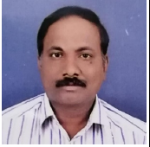

Name of the Faculty : G V Ranga Reddy

Qualifications : M. Sc, B. Ed, (Ph. D), NET

Designation : LECTURER

Department : Botany

Areas of Specialization : Plant Biotechnology

Date of Birth : 05-06-1969

Date of joining in KVRGDC (W): 24-09-2021

Phone No.& Email Id : 9866636833 rangareddybot@gmail.com

No of years of Experience : 13 years 10 months

Academic Achievements

Research: International Publications: 03

Research Projects: 00 Minor: 00

|  |  |  |  |  |
| --- | --- | --- | --- | --- |
| Participation in: | FDP | Seminars | Workshops | Conferences |
| National : | 01 | 08 | 02 | 02 |